HEALTHCARE MANAGEMENT PLATFORM
Color System & UI Style Direction
Visual product requirements for the Doctor & Hospital Management System. The goal is to look advanced and premium without falling into generic AI-dashboard aesthetics.
Brand personality | Trustworthy • Clinical • Modern • Calm • Professional
Primary visual idea | Clinical Command Center — structured, information-dense, low-distraction
Recommended UI approach | Flat / layered enterprise UI with subtle depth; selective modular tiles
Avoid | Heavy glassmorphism, decorative gradients, excessive rounded cards, novelty-first bento layouts

1. Brand Color System
The palette is intentionally blue-led because the product needs to communicate trust and clinical reliability. Teal and green act as supporting health/success signals, while amber and red are reserved for attention and risk.
Color | Hex | Recommended use
Primary Navy | #123B5D | Trust, authority, navigation
Primary Blue | #2563EB | Primary actions, links, active states
Light Blue | #EFF6FF | Selection surfaces, info backgrounds
Teal Accent | #0F9D8A | Health-related secondary accent
Success Green | #16A34A | Completed, safe, positive states
Warning Amber | #F59E0B | Attention, pending, caution
Error Red | #DC2626 | Critical errors, allergy alerts, destructive actions
Background | #F8FAFC | Application canvas
Card | #FFFFFF | Primary surface
Text | #0F172A | Primary typography
Muted Text | #64748B | Secondary typography

1.1 Accessibility notes
- Use Primary Blue (#2563EB) with white text for standard primary buttons.
- Use Teal (#0F9D8A) and Success Green (#16A34A) primarily as status colors, icons, borders, badges, or with dark text on light surfaces; do not rely on white text for small body text on these backgrounds.
- Use Warning Amber (#F59E0B) with dark text rather than white text for readable warning labels.
- Use Error Red (#DC2626) carefully; pair it with white only where contrast is sufficient and with light-red surfaces for longer messages.
- Do not use color as the only indicator of appointment or patient state; pair it with text, icon, or shape.
Accessibility target: design toward WCAG 2.1 AA contrast and keyboard/focus expectations.

1.2 Visual palette reference
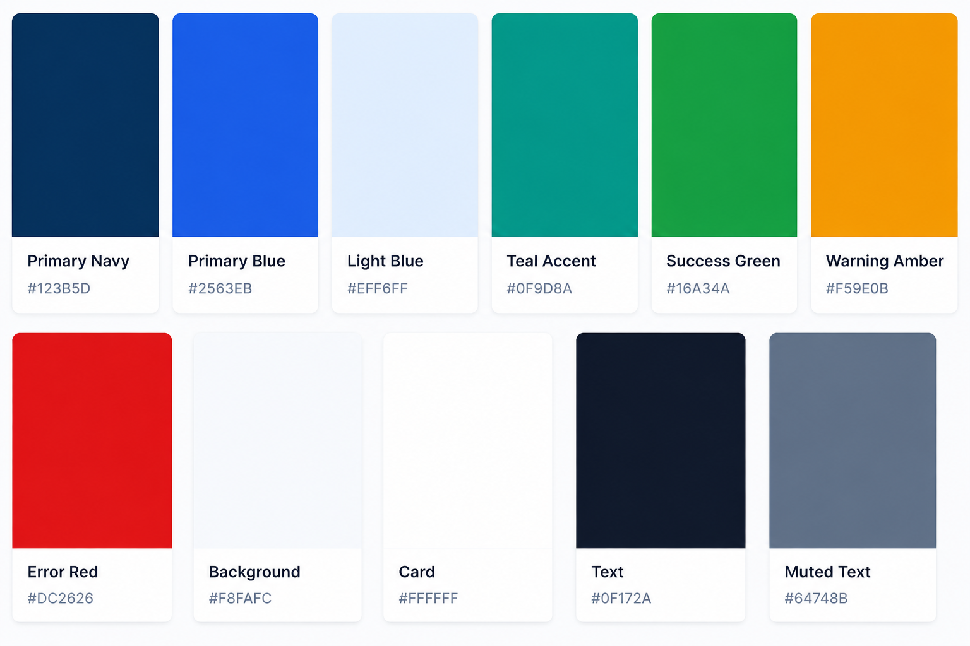

2. UI Style Exploration
The product is operational software used by doctors and staff under time pressure. Therefore the best visual direction is not the most fashionable one; it is the one that gives the highest information clarity with enough polish to feel like a premium SaaS product.
Style | Fit | Recommendation | Why
Glassmorphism | 2/5 | Use only for occasional overlays or utility surfaces | Looks futuristic, but translucency/blur can reduce clarity and feels trend-driven.
Neumorphism / Soft UI | 1.5/5 | Avoid as the main system | Weak hierarchy and contrast problems; poor fit for clinical data-heavy workflows.
Pure Bento Grid | 3/5 | Use selectively on overview/dashboard only | Strong visual hierarchy, but too much tile fragmentation makes clinical workflows noisy.
Minimal Flat / Material-like | 4.5/5 | Strong foundation | Clear, fast, accessible and easy to scale across screens.
Modern Enterprise / Command Center | 5/5 | Recommended | Dense but organized; excellent for schedules, patient lists, alerts, charts and clinical workflows.
Editorial / Luxury SaaS | 2.5/5 | Not recommended | Looks premium but wastes space and can feel like a marketing site rather than a clinical tool.

2.1 Recommended direction: Clinical Command Center
Use a clean enterprise UI with flat white cards, restrained borders, subtle shadows, strong typography, a navy navigation rail, blue primary actions, and compact data components. Use modular/asymmetric blocks only where they improve scanability. The visual sophistication should come from hierarchy, spacing, motion, and component quality—not blur, gradients, or decoration.

3. UI Design Principles
1. Information first: Every major page should have a clear first action and a clear primary data block. Doctors should scan a schedule without opening multiple pages.
2. Layered depth, not glass: Create hierarchy with surface elevation, 1px borders, subtle shadows and spacing. Avoid translucent panels over blurred backgrounds.
3. Selective modular layout: Use different card sizes when the content has different importance. Do not turn every section into a floating rounded rectangle.
4. Moderate radii: Use roughly 8–12px radius for cards and controls. Reserve larger radii for prominent summary modules, not everything.
5. Dense but breathable: Healthcare software needs more information density than consumer apps. Use compact rows, clear dividers and consistent 4/8px spacing rhythm.
6. Status clarity: Appointment states should combine label + icon + color. Example: Waiting, In Consultation, Completed, Cancelled, No-show.
7. Calm motion: Use 150–200ms micro-interactions for hover, dropdown, expansion and status changes. Avoid playful animation.
8. AI is a tool, not the visual hero: The AI panel should feel integrated into the doctor workspace, not like a giant chatbot competing with the patient record.

4. Layout System
- Desktop-first for doctor/reception workflows, with responsive tablet behavior.
- Use a persistent left navigation rail at desktop sizes.
- Use a slim top utility bar for global search, notifications, help, and user profile.
- Main content should use a 12-column grid with consistent gutters.
- Default application background: #F8FAFC. Primary content surfaces: #FFFFFF.
- Use a maximum content width only where it improves readability; dashboards may span the available workspace.
- Avoid excessive empty hero space. This is operational software, not a landing page.

4.1 Doctor dashboard composition
- Top strip: greeting, doctor specialty, date, quick search.
- Compact KPI row: Waiting, In Consultation, Upcoming, Completed.
- Primary block: Today's appointments in Timeline/List or Accordion view.
- Secondary block: Today's overview / workload trend.
- Right or lower utility area: Important alerts, follow-ups, quick actions.
- Calendar view is a first-class alternate view, not the only schedule representation.

5. Component Visual Language
Component | Direction
Sidebar | Primary Navy background; white labels/icons; Primary Blue active indicator or selected background.
Primary button | Primary Blue fill; white text; 8–10px radius; subtle hover state.
Secondary button | White or Light Blue surface; Navy/Blue text; 1px border.
Cards | White surface, 1px light border or very subtle shadow, 8–12px radius.
Table/list rows | Prefer separators and compact row height over floating cards for high-volume data.
Appointment status | Small pill or inline badge. Status label must remain visible in addition to color.
Critical alert | Light red background + red icon/border + explicit text such as 'Allergy alert'.
AI panel | Neutral/light-blue surface with a subtle blue left border or header; compact controls; never full-screen by default.
Modal/drawer | Solid white surface with shadow. Optional very light background dimming; no heavy blur.
Charts | Use blue as primary series; teal/green for comparison; amber/red only for attention or thresholds.

6. How to Make It Look Advanced Without AI-Slop
Use excellent spacing: A consistent 4/8px spacing system and carefully tuned row heights will look more premium than adding glass effects.
Use real information hierarchy: Make the important number or patient state visually dominant; let secondary information recede.
Use contextual expansion: Accordion rows, drawers and inline details reduce page hopping and create a sophisticated workflow.
Use progressive disclosure: Show the minimum needed at first, then reveal history, reports and AI support when requested.
Use subtle motion: Animate state changes, opening panels and navigation with restrained timing.
Use component consistency: Buttons, badges, alerts, inputs and tables should feel like one coherent system.
Use meaningful density: A doctor dashboard should fit useful content above the fold without feeling cramped.

6.1 Specifically avoid
- Glass cards everywhere
- Large gradient blobs behind content
- Every section presented as a separate rounded card
- Excessive 3D or floating UI elements
- Huge dashboard hero headings
- AI sparkle icons dominating clinical workflows
- Neon accent colors
- Animated charts that distract from clinical data

7. Typography
Recommended stack: Inter, IBM Plex Sans, or a comparable highly legible UI sans-serif. Keep typography neutral and clinical.
Level | Suggested size | Use
Page title | 24–28px / 600 | Dashboard or page title
Section title | 16–18px / 600 | Card/section headings
Body | 14px / 400–500 | Default operational text
Dense data | 13px / 400–500 | Tables, appointment lists, metadata
Caption | 12px / 400 | Supporting information

8. Accessibility & Clinical Readability
- Target WCAG 2.1 AA contrast for text and interactive controls.
- Use text + icon + color for statuses and alerts.
- Keep focus states visible for keyboard users.
- Do not use low-contrast muted text for critical information.
- Support 200% text zoom without clipping important content.
- Keep critical patient information and warnings visually prominent and scannable.
Design rationale: Microsoft Fluent's accessibility guidance emphasizes clear hierarchy, predictable navigation, keyboard focus and sufficient contrast; these are especially important for a clinical interface. The design should follow those principles rather than treating accessibility as a final QA step.

9. Final Design Decision
Recommended style: Modern Clinical Command Center
Use a flat, layered enterprise UI as the foundation; borrow the best part of bento layouts—modular hierarchy—only on dashboards. Avoid glassmorphism as a primary surface treatment. The result should feel like a mature healthcare SaaS product: trustworthy enough for clinical work, polished enough to compete with modern enterprise software, and calm enough to keep attention on the patient.

10. Coming Soon — Visual Evolution

Phase 1 — SaaS Admin
- Super Admin and Hospital Admin dashboards using the same design system.
- Plan/feature entitlement management.
- Operational analytics using denser tables and filters.

Phase 2 — Patient Experience
- Patient portal with simpler, calmer layouts than the staff console.
- Mobile-first appointment booking and health timeline.
- Notifications and follow-up surfaces.

Phase 3 — Advanced AI
- Contextual AI assistant integrated into the consultation workspace.
- Report summarization and explanation surfaces.
- AI evidence/source drawer without making AI the visual center of the product.

Phase 4 — Enterprise
- Lab, pharmacy, insurance and multi-branch workspaces.
- Role-specific command centers with progressively denser data views.
- Advanced analytics and configurable dashboards.

Design reference note: The direction favors enterprise healthcare patterns that prioritize scanability, hierarchy, spacing and accessibility. Current healthcare dashboard examples show strong use of appointments, calendars, patient lists and alert panels; the recommendation intentionally avoids copying trend aesthetics as the primary interaction model.

